Module 4. String, StringBuilder, Arrays, and ArrayList

The class String is immutable

■ The class String stores its values in a private variable of the type char array (char value[]). Arrays are fixed in size and don’t grow once initialized.

■ This value variable is marked as final in the class String. Note that final is a nonaccess modifier, and a final variable can be initialized only once.

■ None of the methods defined in the class String manipulate the individual elements of the array value.

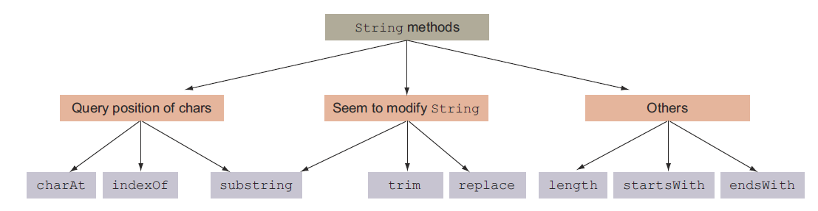

Figure. Categorization of the String methods

Determining equality of Strings

Let’s walk through the equals method defined by class String:

■ compares the object reference variables. If the reference variables are the same, they refer to the same equal object.
■ compares the type of the method parameter to this object. If the method parameter passed to this method is not of type String, returns false.
■ checks whether the lengths of the String values being compared are equal.
■ compares the individual characters of the String values. It returns false if a mismatch is found at any position. If no mismatch is found, returns true.

Mutable strings: StringBuilder

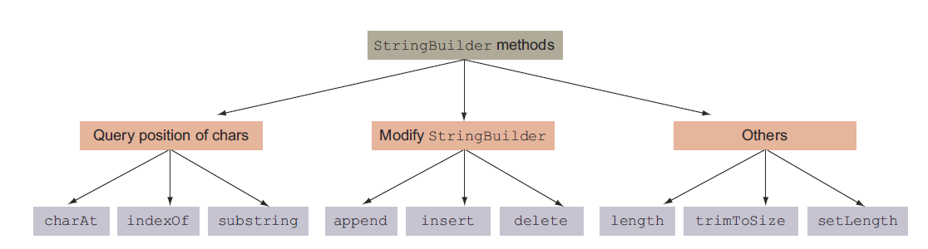

Figure. Categorization of StringBuilder methods

Arrays

What is an array?

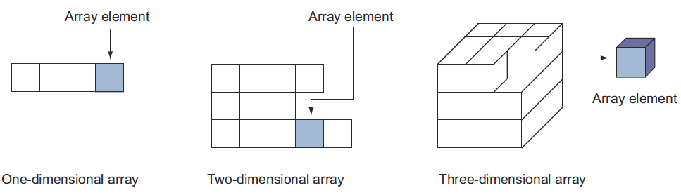

Figure. One-dimensional and multidimensional (two- and three-dimensional) arrays

Arrays of type interface, abstract class, and class Object

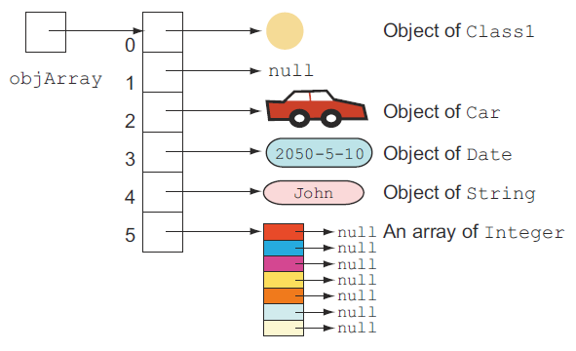

Figure. An array of class Object

ArrayList

■ It implements the interface List.
■ It allows null values to be added to it.
■ It implements all list operations (add, modify, and delete values).
■ It allows duplicate values to be added to it.
■ It maintains its insertion order.
■ You can use either Iterator or ListIterator (an implementation of the
Iterator interface) to iterate over the items of an ArrayList.
■ It supports generics, making it type safe. (You have to declare the type of the elements that should be added to an ArrayList with its declaration.)

Adding elements to an ArrayList

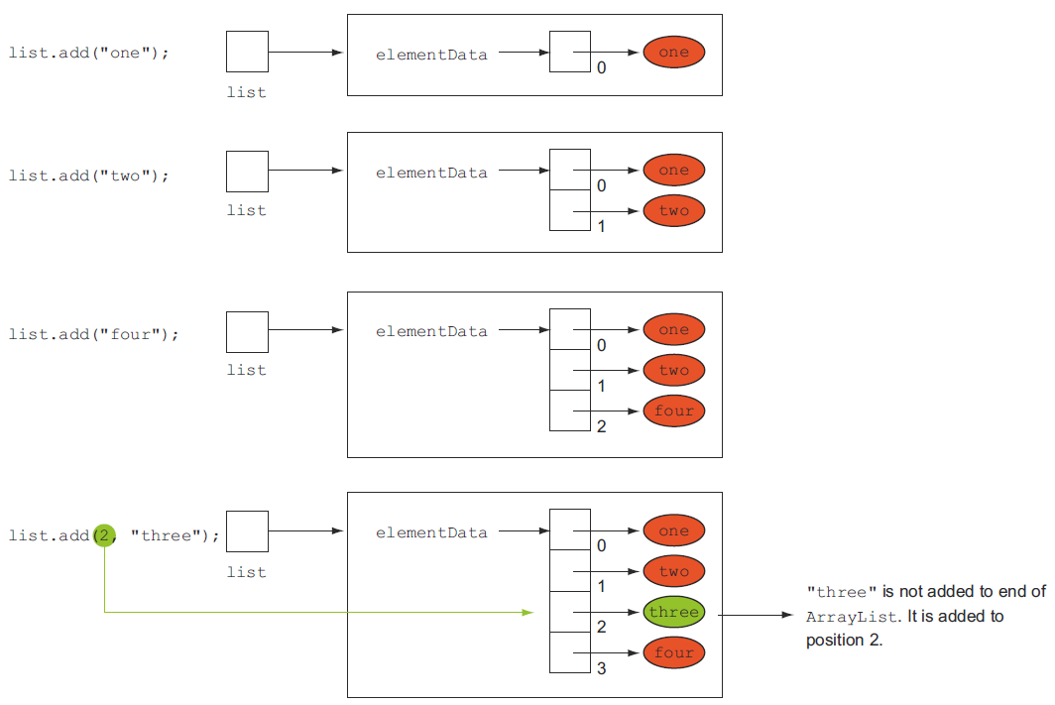

Figure. Code that adds elements to the end of an ArrayList and at a specified position

Comparing objects of a user-defined class

Contract of the equals method

The equals method implements an equivalence relation on non-null object references:
■ It is reflexive: for any non-null reference value x, x.equals(x) should return true.
■ It is symmetric: for any non-null reference values x and y, x.equals(y) should return true if and only if y.equals(x) returns true.
■ It is transitive: for any non-null reference values x, y, and z, if x.equals(y) returns true and y.equals(z) returns true, then x.equals(z) should return true.
■ It is consistent: for any non-null reference values x and y, multiple invocations of x.equals(y) consistently return true or consistently return false, provided no information used in equals() comparisons on the objects is modified.
■ For any non-null reference value x, x.equals(null) should return false.

Review notes

The class String:
■ The class String represents an immutable sequence of characters.
■ A String object can be created by using the operator new, by using the assignment operator (=), or by using double quotes (as in System.out.println
("Four")).
■ String objects created using the assignment operator are placed in a pool of String objects. Whenever the JRE receives a new request to create a String object using the assignment operator, it checks whether a String object with the same value already exists in the pool. If found, it returns the object reference for the existing String object from the pool.
■ String objects created using the operator new are never placed in the pool of String objects.
■ The comparison operator (==) compares String references, whereas the equals method compares the String values.
■ None of the methods defined in the class String can modify its value.
■ The method charAt(int index) retrieves a character at a specified index of
a String.
■ The method indexOf can be used to search a String for the occurrence of a char or a String, starting from the first position or a specified position.
■ The method substring can be used to retrieve a portion of a String object. The substring method doesn’t include the character at the end position.
■ The trim method will return a new String by removing all the leading and
trailing white spaces in a String. This method doesn’t remove any white space within a String.
■ You can use the method length to retrieve the length of a String.
■ The method startsWith determines whether a String starts with a specified String.
■ The method endsWith determines whether a String ends with a specified String.
■ It’s a common practice to use multiple String methods in a single line of code. When chained, the methods are evaluated from left to right.
■ You can use the concatenation operators + and += and comparison operators != and == with String objects.
■ The Java language provides special support for concatenating String objects by using the operators + and +=.
■ The right technique for comparing two String values for equality is to use the method equals defined in the String class. This method returns a true value if the object being compared isn’t null and is a String object that represents the same sequence of characters as the object to which it’s being compared.
■ The comparison operator == determines whether both the reference variables are referring to the same String objects. Hence, it’s not the right operator for comparing String values.

The class StringBuilder:
■ The class StringBuilder is defined in the package java.lang and represents a mutable sequence of characters.
■ The StringBuilder class is very efficient when a user needs to modify a
sequence of characters often. Because it’s mutable, the value of a String-
Builder object can be modified without the need to create a new String-
Builder object.
■ A StringBuilder object can be created using its constructors, which can accept either a String object, another StringBuilder object, an int value to specify the capacity of StringBuilder, or nothing.
■ The methods charAt, indexOf, substring, and length defined in the class
StringBuilder work in the same way as methods with the same names defined in the class String.
■ The append method adds the specified value at the end of the existing value of a StringBuilder object.
■ The insert method enables you to insert characters at a specified position in a StringBuilder object. The main difference between the append and insert methods is that the insert method enables you to insert the requested data at a particular position, whereas the append method only allows you to add the requested data at the end of the StringBuilder object.
■ The method delete removes the characters in a substring of the specified
StringBuilder. The method deleteCharAt removes the char at the specified
position.
■ Unlike the class String, the class StringBuilder doesn’t define the method trim.
■ The method reverse reverses the sequence of characters of a StringBuilder.
■ The replace method in the class StringBuilder replaces a sequence of characters, identified by their position, with another String.
■ In addition to using the method substring, you can also use the method sub-sequence to retrieve a subsequence of a StringBuilder object.

Arrays:
■ An array is an object that stores a collection of values.
■ An array itself is an object.
■ An array can store two types of data—a collection of primitive data types and a collection of objects.
■ You can define one-dimensional and multidimensional arrays.
■ A one-dimensional array is an object that refers to a collection of scalar values.
■ A two-dimensional (or more) array is referred to as a multidimensional array.
■ A two-dimensional array refers to a collection of objects, in which each of the objects is a one-dimensional array.
■ Similarly, a three-dimensional array refers to a collection of two-dimensional arrays, and so on.
■ Multidimensional arrays may or may not contain the same number of elements in each row or column.
■ The creation of an array involves three steps: declaration of an array, allocation of an array, and initialization of array elements.
■ An array declaration is composed of an array type, a variable name, and one or more occurrences of [].
■ Square brackets can follow either the variable name or its type. In the case of multidimensional arrays, it can follow both of them.
■ An array declaration creates a variable that refers to null.
■ Because no elements of an array are created when it’s declared, it’s invalid to define the size of an array with its declaration.
■ Array allocation allocates memory for the elements of an array. When you allocate memory for an array, you must specify its dimensions, such as the number of elements the array should store.
■ Because an array is an object, it’s allocated using the keyword new, followed by the type of value that it stores, and then its size.
■ Once allocated, all the array elements store their default values. Elements of an array that store objects refer to null. Elements of an array that store primitive data types store 0 for integer types (byte, short, int, long), 0.0 for decimal types (float and double), false for boolean, or /u0000 for char data.
■ To access an element in a two-dimensional array, use two array position values.
■ You can combine all the steps of array declaration, allocation, and initialization into one single step.
■ When you combine array declaration, allocation, and initialization in a single step, you can’t specify the size of the array. The size of the array is calculated by the number of values that are assigned to the array.
■ You can declare and allocate an array but choose not to initialize it (for example, int[] a = new int[5];).
■ The Java compiler doesn’t check the range of the index positions at which you try to access an array element. The code throws an ArrayIndexOutOfBoundsException exception if the requested index position doesn’t fall in the valid range at runtime.
■ A multidimensional array can be asymmetrical; it may not define the same number of columns for each of its rows.
■ The type of an array can also be an interface or abstract class. Such an array can be used to store objects of classes that inherit from the interface type or the abstract class type.
■ The type of an array can also be java.lang.Object. Because all classes extend the class java.lang.Object class, elements of this array can refer to any object.
■ All the arrays are objects and can access the variable length, which specifies the number or components stored by the array.
■ Because all arrays are objects, they inherit and can access all methods from the class Object.

ArrayList:
■ ArrayList is one of the most widely used classes from the Collections framework. It offers the best combination of features offered by an array and the List data structure.
■ An ArrayList is like a resizable array.
■ Unlike arrays, you may not specify an initial size to create an ArrayList.
■ ArrayList implements the interface List and allows null values to be added to it.
■ ArrayList implements all list operations (add, modify, and delete values).
■ ArrayList allows duplicate values to be added to it and maintains its insertion order.
■ You can use either Iterator or ListIterator to iterate over the items of an
ArrayList.
■ ArrayList supports generics, making it type safe.
■ Internally, an array of type java.lang.Object is used to store the data in an
ArrayList.
■ You can add a value to an ArrayList either at its end or at a specified position by using the method add.
■ To access the elements of an ArrayList, you can use either the enhanced for loop, Iterator, or ListIterator.
■ An iterator (Iterator or ListIterator) lets you remove elements as you iterate through an ArrayList. It’s not possible to remove elements from an ArrayList while iterating through it using a for loop.
■ An ArrayList preserves the order of insertion of its elements. ListIterator
and the enhanced for loop will return the elements in the order in which they were added to the ArrayList.

■ You can use the method set to modify an ArrayList by either replacing an
existing element in ArrayList or modifying its existing values.
■ remove(int) removes the element at the specified position in the list.
■ remove(Object o) removes the first occurrence of the specified element from the list, if it’s present.
■ You can add multiple elements to an ArrayList from another ArrayList or any other class that’s a subclass of Collection by using the method addAll.
■ You can remove all the ArrayList elements by calling the method clear on it.
■ get(int index) returns the element at the specified position in the list.
■ size() returns the number of elements in the list.
■ contains(Object o) returns true if the list contains the specified element.
■ indexOf(Object o) returns the index of the first occurrence of the specified element in the list, or –1 if the list doesn’t contain the element.
■ lastIndexOf(Object o) returns the index of the last occurrence of the specified element in the list, or –1 if the list doesn’t contain the element.
■ The method clone defined in the class ArrayList returns a shallow copy of this ArrayList instance. “Shallow copy” means that the method creates a new instance of the ArrayList to be cloned, but the ArrayList elements aren’t copied.
■ You can use the method toArray to return an array containing all of the elements in ArrayList in sequence from the first to the last element.

Comparing objects for equality:
■ Any Java class can define a set of rules to determine whether two objects should be considered equal.
■ The method equals is defined in the class java.lang.Object. All the Java
classes directly or indirectly inherit this class.
■ The default implementation of the equals method only compares whether two object variables refer to the same object.
■ Because instance variables are used to store the state of an object, it’s common to compare the values of the instance variables to determine whether two objects should be considered equal.
■ When you override the equals method in your class, make sure that you use the correct method signature for the equals method.
■ The Java API defines a contract for the equals method, which should be taken care of when you implement the method in any of your classes.
■ According to the contract of the method equals, if a null value is passed to it, the method equals should return false.
■ If the equals method modifies the value of any of the instance variables of the method parameter passed to it, or of the object on which it is called, it will violate the contract.

Sample questions

Q4-1. What is the output of the following code?
class EJavaGuruArray {
public static void main(String args[]) {
int[] arr = new int[5];
byte b = 4; char c = 'c'; long longVar = 10;
arr[0] = b;
arr[1] = c;
arr[3] = longVar;
System.out.println(arr[0] + arr[1] + arr[2] + arr[3]);
}
}
a 4c010
b 4c10
c 113
d 103
e Compilation error

Q4-2. What is the output of the following code?
class EJavaGuruArray2 {
public static void main(String args[]) {
int[] arr1;
int[] arr2 = new int[3];
char[] arr3 = {'a', 'b'};
arr1 = arr2;
arr1 = arr3;
System.out.println(arr1[0] + ":" + arr1[1]);
}
}
a 0:0
b a:b
c 0:b
d a:0
e Compilation error

Q4-3. Which of the following are valid lines of code to define a multidimensional int array?
a int[][] array1 = {{1, 2, 3}, {}, {1, 2,3, 4, 5}};
b int[][] array2 = new array() {{1, 2, 3}, {}, {1, 2,3, 4, 5}};
c int[][] array3 = {1, 2, 3}, {0}, {1, 2,3, 4, 5};
d int[][] array5 = new int[2][];

Q4-4. Which of the following statements are correct?
a By default, an ArrayList creates an array with an initial size of 16 to store
its elements.
b Because ArrayList stores only objects, you can’t pass an element of an ArrayList to a switch construct.
c Calling clear() and remove() on an ArrayList will remove all its elements.
d If you frequently add elements to an ArrayList, specifying a larger capacity will improve the code efficiency.
e Calling the method clone() on an ArrayList creates its shallow copy; that is, it doesn’t clone the individual list elements.

Q4-5. Which of the following statements are correct?
a An ArrayList offers a resizable array, which is easily managed using the methods
it provides. You can add and remove elements from an ArrayList.
b Values stored by an ArrayList can be modified.
c You can iterate through elements of an ArrayList using a for loop, Iterator,
or ListIterator.
d An ArrayList requires you to specify the total number of elements before you can store any elements in it.
e An ArrayList can store any type of object.

Q4-6. What is the output of the following code?
import java.util.*; // line 1
class EJavaGuruArrayList { // line 2
public static void main(String args[]) { // line 3
ArrayList<String> ejg = new ArrayList<>(); // line 4
ejg.add("One"); // line 5
ejg.add("Two"); // line 6
System.out.println(ejg.contains(new String("One"))); // line 7
System.out.println(ejg.indexOf("Two")); // line 8
ejg.clear(); // line 9
System.out.println(ejg); // line 10
System.out.println(ejg.get(1)); // line 11
} // line 12
} // line 13

a Line 7 prints true
b Line 7 prints false
c Line 8 prints -1
d Line 8 prints 1
e Line 9 removes all elements of the list ejg
f Line 9 sets the list ejg to null
g Line 10 prints null
h Line 10 prints []
i Line 10 prints a value similar to ArrayList@16356
k Line 11 throws an exception
l Line 11 prints null

Q4-7. What is the output of the following code?
class EJavaGuruString {
public static void main(String args[]) {
String ejg1 = new String("E Java");
String ejg2 = new String("E Java");
String ejg3 = "E Java";
String ejg4 = "E Java";
do
System.out.println(ejg1.equals(ejg2));
while (ejg3 == ejg4);
}
}
a true printed once
b false printed once
c true printed in an infinite loop
d false printed in an infinite loop

Q4-8. What is the output of the following code?
class EJavaGuruString2 {
public static void main(String args[]) {
String ejg = "game".replace('a', 'Z').trim().concat("Aa");
ejg.substring(0, 2);
System.out.println(ejg);
}
}
a gZmeAZ
b gZmeAa
c gZm
d gZ
e game

Q4-9. What is the output of the following code?
class EJavaGuruString2 {
public static void main(String args[]) {
String ejg = "game";
ejg.replace('a', 'Z').trim().concat("Aa");
ejg.substring(0, 2);
System.out.println(ejg);
}
}
a gZmeAZ
b gZmeAa
c gZm
d gZ
e game

Q4-10. What is the output of the following code?
class EJavaGuruStringBuilder {
public static void main(String args[]) {
StringBuilder ejg = new StringBuilder(10 + 2 + "SUN" + 4 + 5);
ejg.append(ejg.delete(3, 6));
System.out.println(ejg);
}
}
a 12S512S5
b 12S12S
c 1025102S
d Runtime exception

Q4-11. What is the output of the following code?
class EJavaGuruStringBuilder2 {
public static void main(String args[]) {
StringBuilder sb1 = new StringBuilder("123456");
sb1.subSequence(2, 4);
sb1.deleteCharAt(3);
sb1.reverse();
System.out.println(sb1);
}
}
a 521
b Runtime exception
c 65321
d 65431

